

**Zetta Elliott**

**Svetlana Chmakova**

**Larry Verstraete**

**Kenneth Oppel**

**Monique Gray Smith**

**Eric Walters**

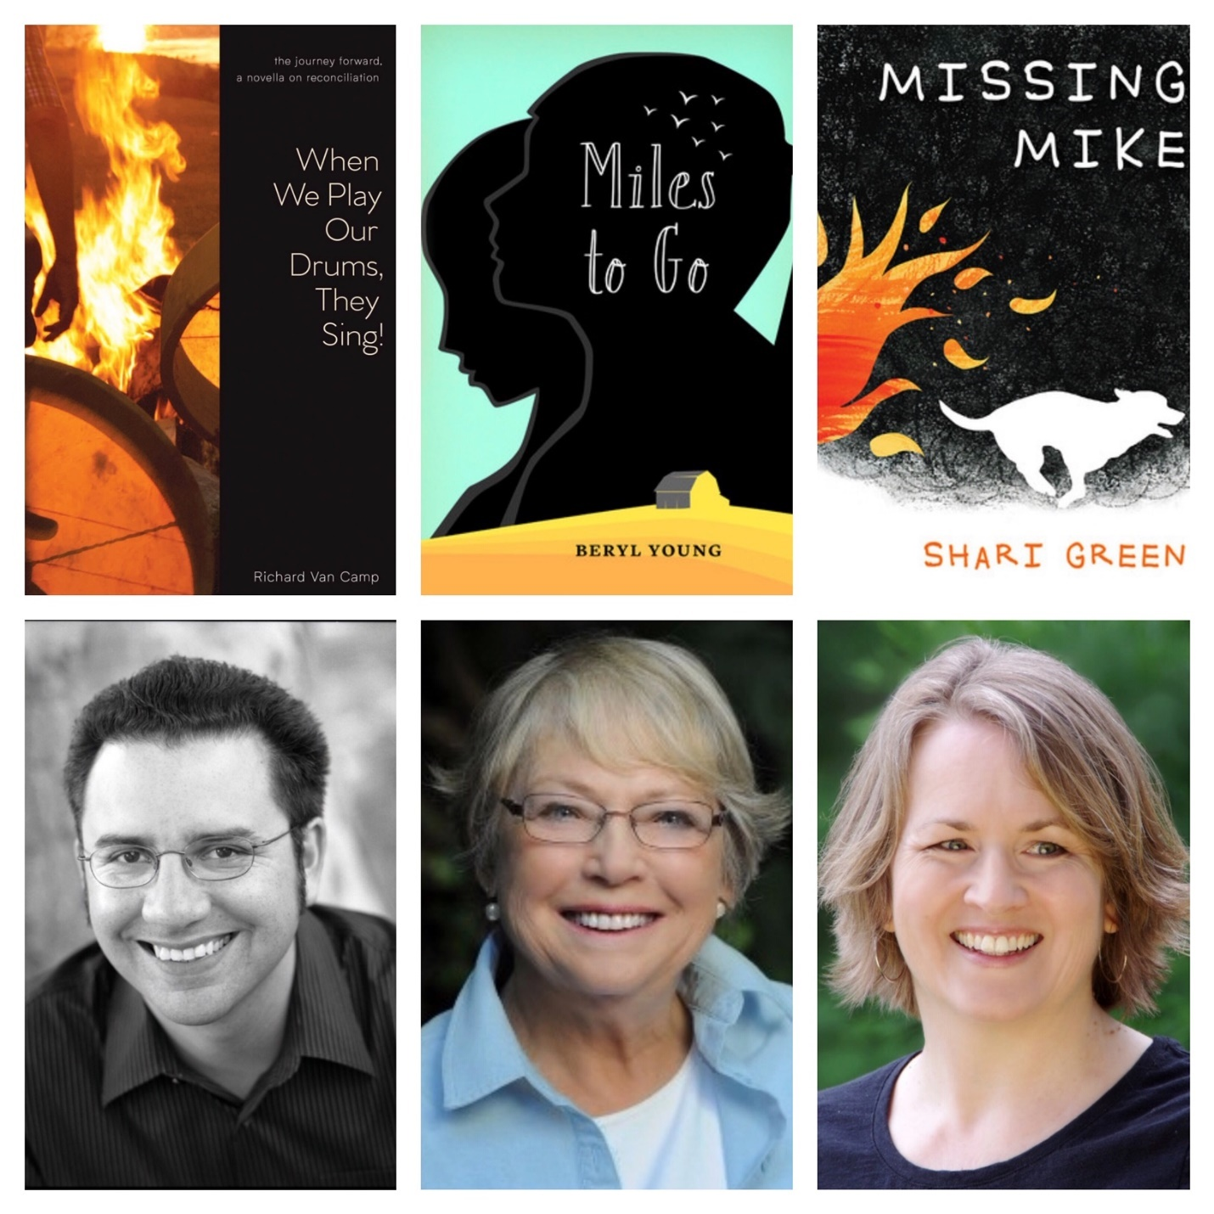

**Shari Green**

**Richard Van Camp**

**Beryl Young**



**Wesley King**

**Lena Coakley**

**Kevin Sylvester**



**Whitney Gardner**

**Marsha Forchuk Skrypuch**

**Heather Smith**



**Colleen Nelson & Nancy Chappell Pollack**

**Susin Nielsen**

**Christopher Paul Curtis**



**Caryn Lix**

**Tasha Spillett**

**E. Latimer**