MYRCA Scavenger Hunt

- Cut out the 20 clues below
- Hide them around the room, library, etc.
- Students must fill in the number blank on the attached sheet with the appropriate letter to solve the phrase

1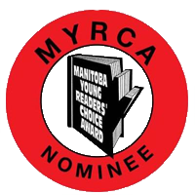C | 2A | 3N | 4A
5D | 6I | 7A | 8N
9A | 10U | 11T | 12H
13O | 14R | 15S | 16R
17O | 8C | 19K | 20!

Find the 20 hidden MYRCA logo clues. Each clue has a number and a letter. The number indicates the blank to fill in. Solve the words by adding the missing letters.

___ ___ ___ ___ ___ ___ ___ ___ ___ ___ ___ ___ ___ ___ ___
1 2 3 4 5 6 7 8 9 10 11 12 13 14 15

___ ___ ___ ___ ___
16 17 18 19 20

Find the 20 hidden MYRCA logo clues. Each clue has a number and a letter. The number indicates the blank to fill in. Solve the words by adding the missing letters.

___ ___ ___ ___ ___ ___ ___ ___ ___ ___ ___ ___ ___ ___ ___
1 2 3 4 5 6 7 8 9 10 11 12 13 14 15

___ ___ ___ ___ ___
16 17 18 19 20

