Northern Lights Word Search
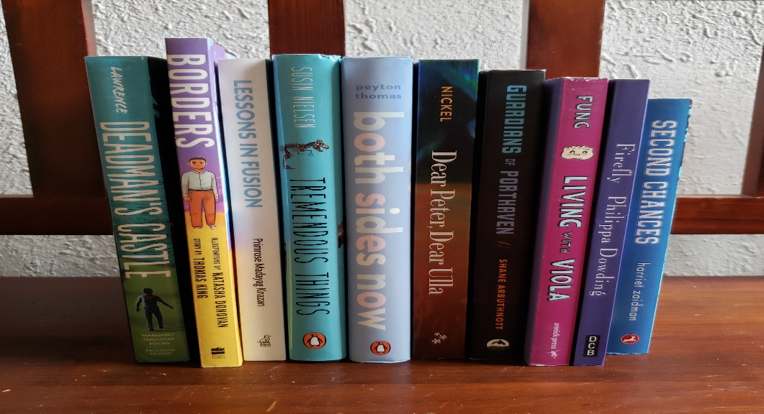
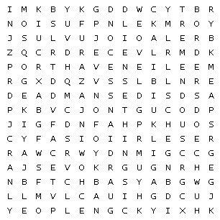

Borders Castle Chances
Fusion Dear Firefly
Living Guardians Lessons
Deadman Porthaven Second
Sides Things Tremendous

