Sundogs Word Search
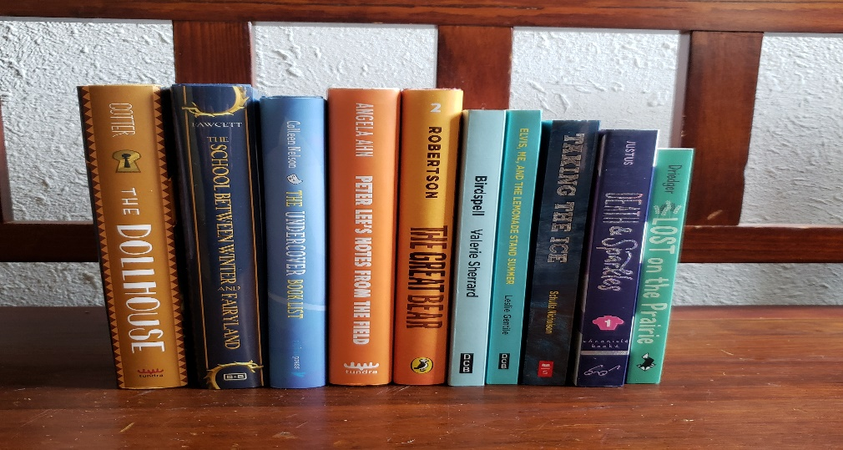

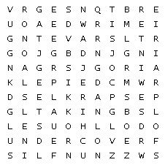

BEAR BIRDSPELL DOLLHOUSE
LEMONADE NOTES PRAIRIE
SPARKLES TAKING UNDERCOVER
Bonus word: WINTER

Words can go in any direction. Words can share letters as they cross over each other.

